

COMSATS University Islamabad Abbottabad, Pakistan

SHADOW RECLAIM: 3D Third-Person Shooter Game

By

Abdul Rehman Ali CIIT/FA22-BSE-088/ATD
Tahir Ali CIIT/FA22-BSE-050/ATD
Ayesha Zohra CIIT/SP22-BCS-093/ATD

Supervisor

Dr. Muhammad Ibtisam Gull

Bachelor of Science in Computer Science (2022-2026)



COMSATS University, Islamabad Pakistan

SHADOW RECLAIM: 3D Third-Person Shooter Game

A project presented to
COMSATS Institute of Information Technology, Islamabad

In partial fulfillment
of the requirement for the degree of

Bachelor of Science in Computer Science (2022-2026)

By

Abdul Rehman Ali CIIT/FA22-BSE-088/ATD
Tahir Ali CIIT/FA22-BSE-050/ATD
Ayesha Zohra CIIT/SP22-BCS-093/ATD

i

DECLARATION

We hereby declare that this software, neither whole nor as a part has been copied out from any source. It is further declared that we have developed this software and accompanied report entirely on the basis of our personal efforts. If any part of this project is proved to be copied out from any source or found to be reproduction of some other. We will stand by the consequences. No Portion of the work presented has been submitted of any application for any other degree or qualification of this or any other university or institute of learning.

Abdul Rehman Ali Tahir Ali Ayesha Zohra




CERTIFICATE OF APPROVAL

This is to certify that we have read the thesis submitted by Tahir Ali having registration number CIIT/FA22-BSE-050/ATD in the session SP26. It is our judgment that this thesis is of sufficient standard to warrant its acceptance by the COMSATS University Islamabad, Abbottabad Campus for the Bachelor of Software Engineering.


l. External Examiner
Anwar ul Islam
Director Software

Bee Technica

- Internal Examiner
Dr. Syed Faraz Ahmed

Supervisor 

Dr. Muhammad Ibtisam Gul

- Head of Department 
Dr. Zia ur Rehman
Department of Computer Science,
COMSATS UNIVERSITY ISLAMABAD,
Abbottabad Campus.
Dated: 11/08/26

This is to certify that we have read the thesis submitted by Avesha Zuhra having registration number CIIT/SP22-BCS-093/ATD in the session SP26. It is our judgment that this thesis is of sufficient standard to warrant its acceptance by the COMSATS University Islamabad, Abbottabad Campus for the Bachelor of Computer Science.

External Examiner 
Anwar ul Islam



Director Software
Bee Technica
- Internal Examiner
Dr. Syed Faraz Ahmed

- Supervisor
Dr. Muhammad Ibtisam Gul

- Head of Department 
Dr. Zia ur Rehman
Department of Computer Science,
COMSATS UNIVERSITY ISLAMABAD,
Abbottabad Campus.
Dated: 11/08/26

This is to certify that we have read the thesis submitted by Abdul Rahman Ali Durrani hat kg registration number CIIT/FA22-BSE-088/ATD in the session SP26. It is our judgment that this thesis is of sufficient standard to warrant its acceptance by the COMSATS University Islamabad. Abbottabad Campus for the Bachelor of Software Engineering.

External Examiner
Anwar ul Islam
Director Software
Bee Technica
- Internal Examiner
Dr. Syed Faraz Ahmed

- Supervisor
Dr. Muhammad Ibtisam Gul

- Head of Department 
Dr. Zia ur Rehman
Department of Computer Science,
COMSATS UNIVERSITY ISLAMABAD,
Abbottabad Campus.
Dated: 11/08/26

EXECUTIVE SUMMARY

Shadow Reclaim is an interactive narrative singleplayer third-person shooter (TPS) that uses the Unity game engine. The game has three opposing factions; the Army, the rebels and you are playing as a neutral agent named Aaren Vale, an agent hired by the government. The point of the game is to be able to have 4 game levels where we have camps, tunnels and key points and gather intelligence in the form of hidden documents.

What distinguishes this game from others is its interactive nature, where the choices of the player alter the entire game ending as well as how the levels and missions play out.

Using these three points as foundations, this game aims to integrate game design, software engineering principles, an interactive story with branching narrative and tactical TPS gameplay in a technically solid manner without straying from the boundaries of the project definition and timeline. The game progresses in levels where the player explores different environments, collecting documents in a campaign with branching paths determined by player choice. The game also integrates basic TPS elements such as shooting, player and enemy controls and intelligence. All the game characters follow an intelligence system within the Unity engine such as navigation based on the Unity Nav Mesh engine, a mix of scripts for various intelligences of AI.

As a game design strategy inspired by agile development practice such as the use of iterations in design and constant testing with a level of flexibility in terms of possible changing of the design and narrative in game if needed (within limits of reasonable bounds of the project scope), this game will be interactive and narrative-driven while incorporating TPS elements.

The scope and limitations of this project will be solely single-player only without any multiplayer and open world.

ACKNOWLEDGEMENT

All praise is to Almighty Allah who bestowed upon us a minute portion of His boundless knowledge by virtue of which we were able to accomplish this challenging task.

We are greatly indebted to our project supervisor “Dr. Muhammad Ibtisam Gull”. Without their personal supervision, advice and valuable guidance, completion of this project would have been doubtful. We are deeply indebted to them for their encouragement and continual help during this work.

And we are also thankful to our parents and family who have been a constant source of encouragement for us and brought us the values of honesty & hard work.

Abdul Rehman Ali Tahir Ali Ayesha Zohra



ABBREVIATIONS

SRS | Software Require Specification
PC | Personal Computer
NPC | Non-Playable Character
AI | Artificial Intelligence
3D | Three-Dimensional
FPS | Frames Per Second

TABLE OF CONTENTS
- Introduction 1
  - Brief 2
  - Relevance to Course Modules 3
  - Project Background 4
  - Literature Review 5
  - Analysis from Literature Review 7
  - Methodology and Software Lifecycle for This Project 8
- Problem Definition 11
  - Problem Statement 11
  - Current System 12
- Requirement Analysis 16
  - Story Boards 17
  - Functional Requirements 22
  - Non-Functional Requirements 25
- Design and Architecture 27
  - System Architecture 27
  - Process Flow/Representation 29
  - Design Models 30
    - Class Diagram 30
- Implementation 41
  - Algorithm 41
  - External Tools and APIs 44
  - User Interface 45
- Testing and Evaluation 53
  - Manual Testing 53
    - System Testing 53
    - Unit Testing 54
- Conclusion and Future Work 57
  - Conclusion 57
  - Future Work 57

LIST OF FIGURES

Fig 3.1 Main Menu Interface 18
Fig 3.2 Level 1 the Hidden Truth 19
Fig 3.3 Level 2 broken Camps 20
Fig 3.4 Level 3 the hidden paths 21
Fig 3.5 Level 4 final decision 22
Fig 4.1 Onion Architecture Diagram 29
Fig 4.2 Class Diagram 32
Fig 4.3 Sequence Diagram 34
Fig 4.4 Sequence Diagram for Mission 35
Fig 4.5 Sequence Diagram for Enemy 36
Fig 4.6 Activity Diagram for Mission 38
Fig 4.7 Activity Diagram 39
Fig 4.8 Activity Diagram for Enemy 40

LIST OF TABLES
Table 3.1 Table1 Player Mechanics 22
Table 3.2 Table1 Interaction System 23
Table 3.3 Table1 Enemy AI System 23
Table 3.4 Table1 Mission and Level System 24
Table 3.5 Table1 Decision and Story System 24
Table 3.6 Table1 Performance Requirements 25
Table 3.7 Table1 Usability Requirement 25
Table 3.8 Table1 Reliability and Stability 25
Table 3.9 Table1 Scalability and Maintainability 26
Table 3.10 Table1 Security Requirement 26

Introduction
Shadow Reclaim is a single-player, third-person shooter (TPS) and narrative-driven adventure that merges tactical combat, environmental exploration and branching narrative choices. Based in the fictional jungle nation of Zerbia players assume the role of a neutral agent, tasked with investigating the escalation of a war between two powerful groups, the disciplined Army and rebel forces. The branching narrative mechanics that this game embodies, directly reward player choice and action. The decision choices the player makes as Aaren the neutral operative ultimately affects the story's path, relationships, and how Zerbia ultimately moves forward.
The initial concept of Shadow Reclaim is primarily concerned with ambiguity and decision making on the part of the player. Rather than the conventional good and evil conflict this game throws the player in with two clearly distinguished, but both morally ambiguous factions that want conflicting thing, with both having a good cause but both having their flaws. As Aaren travels through Zerbia he will discover hidden plots, varying levels of alliances and be forced to make difficult ethical decisions that can change the entire narrative direction of the story depending on how the player chose to progress through events and the people the player chooses to ally with in certain situations.
The core gameplay mechanics are centered around tactical combat while incorporating mechanics that lean towards infiltration and exploration. Combat mechanics are in a third-person perspective allowing for cover-based shootouts, positional advantages when moving and tactical positioning between firefights while also allowing for stealth mechanics so that the player has the option to forgo combat in certain situations and using the environment (Dense jungle for example) to their advantage. Exploration has a significant focus of the game as the players navigate varied environments to search for intelligence and areas of interest, helping them to gain insight into the conflict in Zerbia and also discover new things that add to their gameplay experience.
The environment that players will encounter in Shadow Reclaim will be a pillar within the design of this title. Each distinct area in this world; from unexplored jungle expanses to derelict military bases and enemy controlled territory, will hold significance for both visual and gameplay progression; the player would never find any two parts of a mission to feel exactly the same, nor any two distinct regions. The environment would not only represent and hold significance within its own area; from terrain to types of obstacles within the terrain, but will also be utilized by elements outside of direct game design such as weather and time of day to alter play-style dynamics to improve player agency in relation to tactical positioning.
The decision making mechanics are a core mechanic in Shadow Reclaim in relation to the entire game, each decision that the player makes can lead to different path ways, alter faction morale or allegiance as well as which characters would still be willing to listen or to provide information, if the decision made has negatively impacted that character or faction. The player is able to find different outcomes and multiple endings in this title as the journey to uncover the conflict in Zerbia takes on various pathways dependant on player choice.
Technically the games design would be implemented with modern development techniques and languages, utilizing the unity engine and a C# coding structure, all core systems that govern enemy behavior, mission logic and environmental interaction all operate within this framework and are made extensible in order to handle an ever expanding level of information such as the level of interaction allowed for every area or enemy within the game world, Artificial Intelligence has been utilized to assist the gameplay mechanics creating an enemy that provides appropriate and well thought-out response to combat situations where applicable, while the design of the level and story are made such that every interaction provides a blend between, stealth, combat and storytelling in every mission.
Overall Shadow Reclaim represents a highly immersing and emotional experience that goes past the typical action-focused games, attempting to create a fully believable world with complex story telling combined with tactically sound and deep gameplay mechanics that always provide a chance of outcome or choice, regardless of the players method of progress.

Brief
Shadow Reclaim is a narrative driven, single player, third-person shooter taking place within the thick, unforgiving jungles of the fictional country of Zerbia, focusing on a combination of strategic combat, environment based exploration and narrative manipulation. It abandons conventional "action" style gameplay in favor of player choice and its inherent consequence, allowing a player's decisions throughout the game to shape its path, culminating in one of a number of possible end states.
Players follow a story focusing on a neutral operative, Aaren Vale, who has been commissioned by the government to find a growing, unstable conflict, and investigate, before he is caught within the clash of two major sides; the disciplined Army and the insurgent Rebel group. With neither side aiding either, Aaren is cast in the role of neutral observer and decision-maker within this morally gray war where his impartiality will be challenged at every point, by either the game at large or a player choice to actively engage, on either sides behalf.
The game world, Zerbia, will be a central factor influencing how any game session is played out, characterized by thickly overgrown jungles that hide alternate routes and passages of either abandoned military installations or hastily made rebel camps. The environment will serve not merely as a backdrop but as an obstacle to navigate and a tactical resource, allowing for concealment and stealth when utilizing vegetation, or enabling the player to find hidden paths in order to enter locations that deepen the players' understanding of the war and its immediate effects, or further explore characters.
The core gameplay mechanic is comprised of elements of both intelligent tactical shooting and stealth. Combat has been designed to be strategic as opposed to hyper-action based encouraging the use of stealth and concealment of player character during combat with highly strategic gun fire along with reactive enemy A.I., in a way that creates unpredictable situations and a challenge in their respective resolution. Along with combating such threats, stealth is paramount in order to avoid combat whenever possible, in order to infiltrate locations that allow for a greater understanding of the world through discovered documents and recorded messages, and gather tactical information crucial in advancing throughout game's narrative.
Intelligence gathering plays an enormous role as a narrative driven game mechanic, through obtaining documents, recordings, environmental stimuli and interaction with Non-playable Characters you reveal truths about the expanding war and the reasons why it actually persists. Information that, when gathered, effects the direction of story development through a variety of mission based objectives and character interactions. The more you play this intelligence through by exploring the more you learn from this world.
Intelligence gathering is coupled with a heavily choice driven game, there is an option for what can only be thought of as a narrative based branched out structure through choice: if the player chooses a specific response within narrative dialogue, it will alter relationships with both involved sides as well as change mission based paths through it. Also this games framework provides not simply good and evil but gray area choices where there is no clearly "correct" answer, forcing the player to balance the consequence not simply play to the games wants/needs through a "good" decision in this gray story; but to the right outcome for themselves.
With the two differing and contrasting viewpoints in the form of the Army and the Rebels, there's two distinct ideologies at play in the battle itself: the structured and heavily armed "Army" claiming to have the duty of maintaining and restoring order in the ravaged Zerbia as opposed to the decentralized, oppressed guerilla army known as the "Rebel" fighting for freedom from what is clearly an authoritarian regime, however each side has elements of hypocrisy that is uncovered through play, providing the player with options for both engagement as well as avoidance based on player discretion.
Players are met with main quest objectives, non-essential sub-objectives triggered by various different means such as player exploration and progression, that have dynamic elements due to the aforementioned exploration choices all that combine together to form not only your story but provide depth with others not involved or indirectly involved in this war in differing perspectives. Ultimately, Shadow Reclaim is an experience centered on moral ambiguity, strategic gameplay and choice driven narrative in order to present a different kind of combat and player driven story, emphasizing concepts such as loyalty, truth and the actual and direct human price of conflict while allowing the player to write their own story within it.

Relevance to Course Modules
In essence, this project is the convergence of knowledge and skills gained across multiple academic modules. By effectively blending technical development, design considerations, and the intricacies of interactive system design, it manifests into a cohesive game development framework. To achieve the core game mechanics required for a third-person shooter, core concepts are applied within the Unity game engine, where aspects such as the overall environment, character control systems, animations, the physics interactions and gameplay logic are all implemented in a robust and organized manner to build a cohesive experience around each other.
Therefore, Unity is selected as the fundamental platform around which each aspect required for development such as the environments that host the player, other game assets, interactive systems and the overall user’s gameplay experience will be centered.
This project is a representation of multiple academic fields culminating in a fully produced and interactive experience.
C# programming is applied across the projects development, providing the engine of the game to ensure all interactive features of the player and opponents are functional and interact in a cohesive manner. Such programming features will include the design of the player control system, any combat systems, scripts for the artificialintelligence of enemies and the internal logic for any mission-based progression, player inventory and other forms of in-game interaction to name a few. By employing object-oriented programming concepts such as Encapsulation, inheritance and Polymorphism, the codebase can be constructed more logically, promoting reusability and ease of management to the different component systems (e.g. Weapon systems, enemy types, mission logic etc) all operating concurrently but still able to inter-act harmoniously with each other within the game engine.
To accommodate the structured execution of the project, several principles of software engineering such as iterative development methods and modular design can be implemented throughout the design and development phases of the project. For the entirety of the projects lifecycle, planning will be done in a series of phases where at each step the overall aim or result of that stage will be documented as requirements analysis, systems design, implementation and even iterative testing and feedback gathering to refine all aspects. Continuous development is maintained through rigorous version control management to keep the current changes isolated from other branches and well-systematic debugging to address the majority of any technical challenges faced throughout development time.
Furthermore, artificial intelligence is applied to allow for increased challenge and realism within the game experience for the player particularly when it comes to opposing enemy mechanics. AI are to control how an enemy detects, responds to and interacts with the player through actions such as moving within the level, decision-making through scripted behaviours (e.g. Cover system, flanking manoeuvring and retreating strategies) and their attack patterns depending on player action to create a far more immersive and engaging combat experience simulating well-managed and reactive humanoid opponents.
Additionally human-computer interaction principles can be implemented into the project to create an experience with excellent and intuitive usability for the player. By ensuring that UI is clear, controls are responsive and the visual and audible feedback given to player action from the game environment is immediate, the system itself aims to eliminate user frustration by providing transparency to all game mechanics and decision making by simply creating a user-centric experience.
In conclusion, this project represents the complete integration of a wide range of academic areas combining our learned programming languages and methods, and applying software engineering principles to manage its execution and creation; implementing artificial intelligence to create reactive and responsive enemies; and integrating human-Computer interaction to provide intuitive and accessible gameplay to the user.

Project Background
Current 3rd person shooter titles appear to favor visual splendor, rapid combat and a single approach to mission completion often forsaking player decision's impact. While cinematics are frequent the narrative impact they bring are generally minimal to overall game progress/ending possibilities and, in particular with 3rd person shooters (TPS) Shadow Reclaim strives to combat this very issue by combining a tactical shooter combat system with a massively branchable narrative where the player choice actually dictates story progress.
In Shadow Reclaim play extends beyond simple fighting action. Every mission as well as interaction actually takes a piece of the developing story in to account due to your every moral and combat decision you make in every scenario encountered. Whether it be about choosing between believing the Army and trusting the Rebels or the moral direction you wish to proceed with captured enemies to which data you wish to obtain first, the action will flow as per the choices made. This is far more involving than simply playing through set action pieces, however in this TPS you directly manipulate the political and emotional climate of your world.
The jungles of Zerbia are a vital part of enhancing this. Instead of linear maps prevalent to typical TPS, Zerbia has a vertically interconnected world and vegetation that effects all gameplay elements. The dense jungle can allow for you to strategically ambush groups of enemy soldiers, or remain stealthy to avoid confrontation all while providing obstacles for you to overcome during traversal using the complex terrain, rivers, cliffs and abandoned shanties as the path ahead, forcing you to really consider your routes in to each section of the mission you may face.
Environmental manipulation is key to this game. You have trees and rocks to cover you from enemies and elevated structures from which you will utilize cover. Whether the atmosphere changes in to heavy rain where visual scope is dropped by enemies for or visibility drops from the foliage of the jungle terrain each engagement is unique based on this and can change based on all that and a changing world.

Literature Review
Studies within modern game development repeatedly find that engaging player experience arises when gameplay mechanics and narration are closely interwoven as single entities, not as separate parts of gameplay. Specifically, TPS studies found that while gameplay systems must maintain responsive combat controls, sustained player engagement is derived from the context in which a particular set of game mechanics is framed within a storyline-driven situation. This context requires a set of game mechanics from combat to stealth to exploration and to character decisions (all working coherently) that affect narrative outcomes in order to gain that emotional engagement.
In TPS design one of the key factors of engagement is the combat systems within games. Studies found that the combat is meant to challenge the player in controls, weapons, and enemies; but it will not succeed without other mechanics that supplement and aid combat. Therefore, the environment and level design play as crucial an aspect in combat game design as it does elsewhere: the environment guide the players through the space, creating natural paces between areas of play.
Terrain features allow for strategic positioning (or lack of) creating both challenge as well as providing places to rest out of enemy line of sight.
Environmental and level design not only allows the enemies to approach the player strategically with variety rather than approaching through hand-scripted pathing that would become monotonous, but also helps give the player a sense of discovery as to what the level may look like, and how the player should prepare to proceed. Player interaction is perhaps the biggest challenge as studies showed that player interaction was not only related to how they controlled actions (as input) to fight but to also interact with others within the world of a game. Players who feel more in control of their decisions within an environment through interaction not only learn the role of their character in a story but also develop a stronger sense of emotional connection, such as exploration, storytelling, or manipulation of a particular object/element in the game world.
Unity is one modern engine that has NavMesh which is widely regarded as being standard with its implementation as a realistic method of efficiently navigating the AI agents. An object defining the terrain the game plays on can determine what sections of an environment AI can traverse so as to avoid collisions with objects within. NavMesh allows agents to navigate a given 3-d terrain realistically by having it calculate an optimal route around objects, and in complex environments like jungles, ruins, or vertically tiered levels, this will allow the enemies to attack and chase player intelligently along the navigable sections of levels in a responsive way without manual movement calculations for every enemy instance; but with the terrain as NavMesh one would not need to manually control enemies as each one is navigating along the set pathways of a level inherently.
Structured mission design was also shown to be one of the more engaging ways to promote and expand player progression.
This type of level design allows the player to progress through the mission and story but will offer variety so that progression isn't just a string of repeated actions.

Analysis from Literature Review
According to literature studies, "choice" in player input leads to an increase in player enjoyment and replayability within most modern game genres. It enables "player agency" within the narrative which builds on emotional stakes within the game world, and leads players to desire to see alternative routes in replay to witness differing outcomes and ends. Within Shadow Reclaim this should be considered: Each playthrough in the campaign may differ based on the faction which the player interacts with throughout it, in how critical decisions within the conflict between Army and Rebel are made in Zerbia, and in what manner a certain moral situation is perceived.
The importance of artificial intelligence is highly relevant to creating compelling challenges in game worlds.
NavMesh technology implemented in Unity allows for the rapid and precise calculation for enemies, especially important for jungles which have dense coverage and diverse paths which enemies will navigate between. Using NavMesh, artificial intelligence characters are able to calculate paths around natural cover, odd terrain, and environmental objects, which in this case is extremely important given Zerbia is a jungle planet with natural coverage, vertically ranging paths, and many hidden spaces. Because the AI characters are able to navigate around its challenges efficiently, they are able to pursue, flank and react to player maneuvers realistically. In addition, they can implement sophisticated behavioral practices.
Using artificial intelligence technology, enemies can flank, retreat, regroup under pressure, and react to enemy and ally placement dynamically, providing for not only compelling challenges, but a realistic atmosphere as well.
Finally mission design needs to be balanced and engage the player, especially with game genres that feature multiple level paths like this one. A structured mission system incorporates objective based design which progresses the narrative throughout level exploration, combat and task completion at a speed in which gameplay never becomes too repetitive and presents the player with continuous new mechanisms and challenges to learn, in Shadow Reclaim mission based design takes into account both narrative relevance to gameplay elements, such as exploration and mission related objectives, and combat involving different enemy factions on a vast landscape, with added bonus replay ability.

Methodology and Software Lifecycle for This Project

Shadow Reclaim's development process relies on an iterative approach-similar to that used in Agile software development-emphasizing flexibility, progressive improvement, and staged feature integration. Given the nature of game development, a feature-rich game like Shadow Reclaim demands iteration, especially as the mechanics, narrative and technical systems of the game evolve based on tester feedback and design decisions. Instead of undertaking all system processes in a linear cycle, the design of Shadow Reclaim has been divided into smaller, manageable steps that enable constant assessment and iteration.
The first stage consists of a detailed analysis of requirements, wherein the fundamental concept of the game has been established. In this phase, required game mechanics, narrative development and architecture specification were identified, along with any technical constrains that accompanied these definitions. Requirements include not only basic third-person shooter mechanics and expected AI performance levels and design-behavior. The aim of this process is to build up an idea in developers' minds of what and how the game has to function and, in many cases, which elements might interact under various conditions.
Once the requirements for the game are known and laid out, the process continues to the system design phase; the architectural principles of Shadow Reclaim as a whole were laid out during this stage-and this involved designing how various modules are structured in the Unity game engine using C# so that they are independent of each other and thus allow easy manipulation without affecting or corrupting other parts of the game systems; such systems include the player movement, AI behaviors, shooting mechanics (both player and enemies) and how missions in general will be executed. Level structures and narrative flow (as well as interaction between this narrative and the mechanics and gameplay systems) are the key aspects of the system design stage that are addressed at this time.
After having defined a structure based on determined needs and system interactions, it has been the turn of the implementation phase, a process of development wherein the actual game systems within the Unity engine are developed. This phase involves the coding of basic third-person shooting mechanics and artificial intelligence, with various modes of the gun-action set for every enemy type; player control and interaction systems, along with basic mission progression and other sub-level logic systems were also programmed during this stage, alongside environmental models, animations and any audio sources to produce what would be initially a functional, albeit unpolished version of Shadow Reclaim, each feature iteratively added, programmed and fine-tuned during this step.
The process of testing is conducted throughout development-not exclusively once all has been implemented, as is the case with linear development processes. Both performance and functional testing were undertaken on various stages of the implementation and beyond; testing also included evaluation of how the players experience Shadow Reclaim, which also enabled identification of potential improvements based on that feedback; game mechanic aspects such as the weapon feel and responsiveness, and overall AI challenge were continually adjusted throughout this phase based on their performance and player impact during playtesting until a satisfying gameplay and overall flow were ensured for the player that interacts with the game.
The final stage involves putting everything into practice and polishing and testing the overall design. This include last performance tweaking, visual and audio refinement, alongside overall system cohesion testing so as to guarantee a good final result ready for presentation or, perhaps in the future, commercial release and eventual updates following their first release, due to the iterative nature of the development cycle being a key element throughout the construction of Shadow Reclaim.
Thus, the iterative nature of development on Shadow Reclaim allows both the overall structure and the individual game mechanics and systems a much greater chance to achieve the vision initially set while also ensuring stability due to repeated testing and evaluation at every step throughout development until the eventual full implementation of the game.

Rationale behind Selected Methodology
An Agile based development process was selected for Shadow Reclaim largely due to the iterative, fluid and evolutionary nature of game development itself. Unlike linear forms of development processes, Agile based development practices foster continual feedback, refinement and iterative improvement of both technical systems and creative aspects. In game development in particular which aims to combine many elements of combat mechanics, artificial intelligence behaviors, branching storylines, as well as complex and interactive environments, requirements tend to shift during the course of the project as new ideas emerge or testing uncovers unknown problems. The ability to accommodate such change as a requirement necessitates a natural ability to be able to adapt to fluctuating requirements, which is a core characteristic of Agile.
Developing game components such as third-person combat, AI behavior, a branching narrative or even simple mechanics of environment interaction, will be difficult to predict precisely in advance. Testing must be performed repeatedly on each one of these systems until a suitable level of performance, difficulty or responsiveness is achieved, and this testing can only occur if development continues in cycles where features are built, tested, then iteratively refined rather than finishing all development work, then proceeding to full scale testing toward the end of the project. Iterative Agile based development supports development by small chunks of work that can be independently tested and verified, minimizing the likelihood that serious design flaws go unnoticed until late in the project, at which time they become substantially harder and more costly to rectify.
An important benefit of this development method is the inherent flexibility it has. As the project of making Shadow Reclaim is undertaken certain aspects of mechanics, be they the enemy artificial intelligence, story progression, or character decision interaction, will eventually be modified based on the outcomes of tests conducted on earlier versions of Shadow Reclaim. When such changes are need Agile allows them to be inserted into development without disrupting the development pipeline to a large degree, thus allowing the game to slowly iterate to a more polished form.
An additional major benefit of this process is the constant and rigorous testing being applied not only at the end of each build. When every build is expected to remain largely playable, it is easier for an Agile based process to test each individual component of the game mechanics for issues whether they are related to shooting accuracy, ease of movement, artificial intelligence reactions in the jungle or even how far each mission plays out. Quick and immediate identification and resolution of issues means fewer overall problems for testers down the line.
Another critical advantage from this system is issue resolution speed. Certain issues with artificial intelligence in a specific terrain environment or even how certain parts of a quest line fail to transition properly are bound to pop up in Shadow Reclaim, and as these may have effects which prevent another mechanic's full functionality from being realized during a test session it may be beneficial to solve the problem with minimal time delay lest a cascade of other development be halted in due time, the quick and efficient fixing enabled through an Agile methodology prevents this by resolving issues in the smallest possible window.
Another massive benefit toward developing Shadow Reclaim this way is the continuous improvement that it is enabled to offer in gameplay and player experience. All feedback provided during testing, gameplay or on any part of Shadow Reclaim at that may come up, can be used by Agile development practices to immediately alter features such as combat, player difficulty and controls, such that even if gameplay isn't perfect it will become progressively more perfect as development continues, and the player will have a better experience.

Problem Definition
As the gaming industry has been developing over the years, players are expecting more immersive environment, intelligent non-playable characters (NPC) and interactive plots from games. However, most of the third-person shooter (TPS) games still use linear gameplay where missions and story outcome is pre-defined and unchangeable by the player. This will reduce the interest of the player to play the game and lessen the replayability of the game.
Besides that, the artificial intelligence of the games are also very predictable as the enemies always follow the same pattern which makes the game less challenging and realistic. The environment of the game is also not well used as it is just a static background of the game without doing anything to the gameplay.
Furthermore, there is also a lack of proper integration between gameplay and narrative between the combat, game environment and story decision.
Hence, the problem being faced by this project is to integrate multiple complex systems together into one single cohesive system which includes gameplay and narrative.

Problem Statement

The main problem of this project is to design and develop a third-person shooter game which integrates multiple complex systems together into one single cohesive system which includes gameplay and narrative.

The main challenge of this project is to integrate multiple complex systems together into one single cohesive system which includes gameplay and narrative. Particularly, the system must allow for player decisions to have an impact on the mission progress, relationship with different factions and the story outcome without compromising on gameplay balance.

Therefore, the problem can be stated as follows: To design and develop a unified third-person shooter system which integrates tactical combat, intelligent artificial intelligence, game environment and story decision into one single cohesive system which enhances gameplay and replayability of the game.

Proposed System /Solution
Shadow Reclaim proposed a unified third-person shooter system which integrates tactical combat, intelligent artificial intelligence, game environment and story decision into one single cohesive system which enhances gameplay and replayability of the game.
The system design will make use of branching narrative system where player’s decision will affect the mission progress, relationship with different faction and outcome of the mission. The intelligent artificial intelligence will allow enemy to detect and follow the player and eventually engage in combat with the player. The environment of the game will allow player to make use of the terrain and cover to their advantage. The gameplay of the game will be mission-based progression system with decision-making to increase the replayability of the game by ensuring all gameplay are interconnected.

Current System
Existing third-person shooter games are mostly combat-based games where the gameplay will be to complete a set of missions with fixed objective and outcome. The outcome of the story will also be linear and player’s choice of action will not affect the overall story of the game. Therefore, the gameplay of the game will be the same for most of the playthroughs which will decrease the replayability of the game.

On the other hand, narrative-driven games that offer branching storylines and player choice frequently lack sophisticated combat systems or gameplay mechanics that allow for player interaction. Likewise, games that place a heavy focus on artificial intelligence and environmental interaction offer gameplay in which these features are present, but they do not integrate narrative progression in any significant way.
Because of this differentiation, current game systems fail to provide gameplay in which a cohesive integration of combat, exploration, artificial intelligence, and story are all working together in a meaningful way. Instead, the gameplay is broken into separate components where the player is unable to experience interaction between his or her actions and the game world.

Deliverables and Development Requirements
The development of Shadow Reclaim includes a defined set of deliverables and technical requirements that ensure the game is fully functional, structured, and aligned with its design objectives. The primary deliverable is a complete single-player third-person shooter game built within the Unity engine, designed to provide an immersive and interactive gameplay experience. This includes the creation of four fully developed game levels, each with progressively increasing difficulty to ensure smooth player learning and challenge scaling throughout the game.

Another major part of the project is the implementation of a choice-based storyline system that provides players with different narrative paths and possible endings. The decisions players make throughout the game directly affect how the story develops, their relationships with different factions, and ultimately the outcome of the game. The project also includes interactive non-playable character (NPC) systems and faction mechanics based around the two main opposing groups: the Army and the Rebels. These systems allow the player to interact more naturally with the game world while adding greater depth to the story and its moral choices.
The game also features a functional enemy AI system developed using Unity’s NavMesh technology along with scripted behaviors. This allows enemies to move through different environments, react to the player’s actions, and participate in combat situations. An in-game mission objective system has also been added to guide the player through the story. In addition, players can collect documents and intelligence items, which help reveal more information about the story and the game world. A basic user interface is included to display important information such as the player’s health, current objectives, and interaction prompts. Finally, the project provides a complete executable build that can be used for testing, demonstrations, and evaluation.
From a technical point of view, Shadow Reclaim is developed using the Unity game engine, which handles important aspects such as graphics rendering, physics, animation, and overall system integration. C# is used for programming the core gameplay systems, including player controls, enemy AI, mission tracking, and interaction mechanics. The game is developed for PC, with Windows as the main target platform. For the environment, the game uses a 3D low-to-medium polygon jungle setting. This approach helps maintain good performance while still providing enough visual detail to create an immersive environment suitable for the dense and challenging setting of Zerbia.
The game includes several core gameplay mechanics, including player movement such as walking, running, crouching, aiming, and shooting. An interaction system allows players to interact with objects, documents, and other elements within the environment. Enemy detection and combat behaviors are also implemented so that AI-controlled enemies can react to the player’s presence and actions. The mission tracking system keeps track of objectives and updates them as the player moves through the game. At the same time, the dialogue and decision-making system allows players to make choices that affect the direction of the storyline. A level progression system is also included to manage movement between different stages and maintain a clear flow of gameplay.
In terms of non-functional requirements, the game is designed to run smoothly with minimal lag, even when the environment contains multiple AI-controlled enemies and interactive elements. The controls are designed to be responsive and easy to understand, allowing players to focus on exploration and combat without unnecessary complexity. The AI system is also designed to support different difficulty levels by adjusting factors such as enemy behavior, reaction time, and tactical responses. Overall, the project focuses on stability and reliability, with the aim of preventing critical runtime errors and providing a consistent gameplay experience across different levels.

. Current System
Currently, there is no fully integrated system that brings together all the core features planned for Shadow Reclaim within a single, cohesive third-person shooter (TPS) framework. Most existing games focus on only some of these features, with gameplay and narrative systems often being developed separately rather than working together as one connected experience. Because of this, players may get games with strong combat mechanics but limited storytelling, or games with engaging stories but less interactive gameplay.
Traditional TPS games usually place most of their emphasis on combat. Shooting, weapon handling, enemy encounters, and mission completion are often the main focus of the gameplay. Although these games can offer smooth and well-developed action mechanics, their stories are generally linear and predetermined. Even when player choices are included, they often have little effect on the storyline or final outcome. This reduces the player's sense of control and can also limit replayability, since subsequent playthroughs tend to follow almost the same path.
In contrast, narrative-driven games put more emphasis on storytelling, character development, and player decisions. They may include branching dialogue, moral choices, and different outcomes based on what the player decides. However, these games often do not provide the same level of tactical combat or interactive gameplay found in action-focused titles. As a result, gameplay can sometimes feel secondary to the story, giving players less involvement in the moment-to-moment action and strategic aspects of the game.
There are also survival, stealth, and AI-focused games that make use of advanced enemy behavior, environmental interaction, and dynamic gameplay systems. These games can provide intelligent AI, stealth mechanics, and environments that react to the player's actions. However, they generally do not combine these features with a structured faction-based storyline where player decisions have long-term consequences. Instead, the emphasis is usually placed on survival, stealth, or open-ended gameplay rather than maintaining a strong connection between gameplay actions and story progression.
Looking at these different types of games together, a clear gap can be identified. Many existing game designs do not fully combine combat, exploration, artificial intelligence, and decision-based storytelling into one interconnected system. Instead, these elements are often developed independently, which can result in a fragmented experience where some systems are much more developed than others. When gameplay systems are not properly connected, players may also find it difficult to see how their actions affect both the game world and the direction of the story.
To address these limitations, Shadow Reclaim is designed as a unified, mission-based third-person shooter that combines tactical combat, environmental exploration, intelligent AI behavior, and branching narrative elements. The different systems are designed to work together rather than operate independently. Player decisions can affect faction relationships, mission progression, and the eventual ending of the story, creating a stronger connection between gameplay and narrative. By bringing these elements together, the project aims to provide a more immersive, engaging, and replayable experience while addressing some of the limitations found in existing games within the genre.

Requirement Analysis
Requirement analysis establishes a clear understanding of what Shadow Reclaim needs to achieve in terms of functionality, performance, and overall user experience. Since this phase provides the foundation for the entire development process, it is important to identify and document the required gameplay systems, technical limitations, and design expectations before implementation begins. Clearly defining these requirements at an early stage helps organize the development process, reduces ambiguity, and lowers the risk of missing or inconsistent features later in development.
The process begins by identifying the major gameplay elements and ensuring that they are aligned with the overall vision of the game. This includes defining how the combat system will work, how enemy AI will behave, how players will interact with the environment, and how narrative decisions will affect the progression of the story. Each of these systems needs to be considered individually as well as in relation to the other systems. A smooth gameplay experience depends on these features working together rather than functioning as completely separate components.
Combat is one of the main areas covered during requirement analysis. The combat requirements define the player's movement, aiming, shooting, and interaction with enemies from a third-person perspective. They also cover aspects such as weapon behavior, damage mechanics, and feedback provided to the player during combat. Alongside combat, the requirements for enemy AI define how enemies detect the player, navigate the environment, and react to different situations during gameplay. These requirements are particularly important because the game takes place in a jungle environment, where terrain, visibility, and environmental complexity can have a significant effect on both player movement and enemy behavior.
The interaction system is another important part of the requirements. It covers interactions with objects, documents, NPCs, and other elements within the game world. The system needs to be simple and responsive so that players can interact with their surroundings without unnecessary confusion. The narrative decision system is also defined during this stage. It determines how choices are presented to the player and how those choices affect mission progression, faction relationships, and the eventual outcome of the story. Because player interaction is closely connected to both gameplay and narrative progression, it plays an important role in shaping the overall experience.
The requirements are divided into two main categories: functional and non-functional requirements. Functional requirements describe what the game should be able to do. These include core features such as player movement, combat, enemy AI, mission tracking, environmental interaction, dialogue, and decision-making. Defining these requirements ensures that the game contains the necessary features to provide a complete and interactive gameplay experience.
Non-functional requirements, on the other hand, describe how the game should perform and how users should experience it. These requirements include performance, usability, scalability, and system stability. The game should maintain smooth gameplay with minimal lag, provide responsive controls, and use an interface that is clear and easy to understand. Scalability is also considered, particularly for systems such as enemy AI, where different difficulty levels may require changes to enemy reaction times, behavior, and tactical responses. These adjustments should not have a significant negative impact on overall performance.
Overall, requirement analysis provides a clear structure for the development of Shadow Reclaim and ensures that the planned systems remain aligned with the game's objectives. By separating functional and non-functional requirements and examining each major gameplay component, this phase provides a strong foundation for developing a stable, efficient, and engaging game.

Story Boards
A storyboard is a visual planning tool used to show the sequence of gameplay, scenes, and player interactions in a game. It helps developers understand how the game progresses from one stage to another by outlining elements such as the user interface, level structure, player actions, and decision-making points. In Shadow Reclaim, the storyboard presents the player's journey from the main menu through different levels, including key activities such as combat, exploration, and narrative decision-making.
Figure 3.1 shows the storyboard for the game's main menu. The title Shadow Reclaim is displayed prominently at the top of the screen and is designed to match the game's jungle warfare theme. The background contains hand-drawn jungle elements, including trees and the silhouette of a soldier holding a weapon. These visual elements help establish the game's military setting and give the player an initial impression of its third-person shooter (TPS) gameplay.
The main menu contains the following options:
- Start Game – Starts a new game session.
- Load Game – Allows the player to continue from previously saved progress.
- Options – Provides access to settings such as controls and audio.
- Exit – Closes the game.
The menu uses a simple and easy-to-understand layout so that players can navigate it without difficulty. The jungle and military-themed visuals also help establish the atmosphere of the game before the player enters the main gameplay. Overall, the storyboard provides an early representation of the game's structure and helps define how the player will move through the different gameplay and narrative elements.
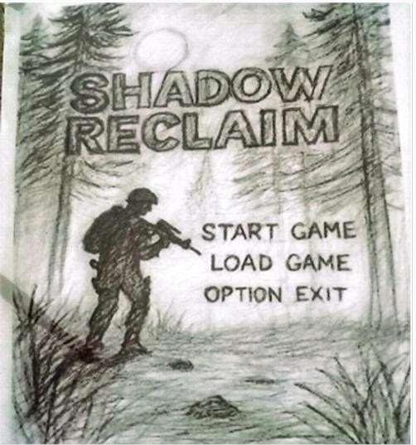

Figure 3.1 Main Menu Interface

In Fig 3.2 storyboard represents the first level of the game, titled The Hidden Truth. It introduces the player to the environment, objectives, and core gameplay mechanics.

Key elements shown in the image include:
- Jungle setting with large trees and camps (Camp 1 and Camp 2), indicating exploration areas
- Helicopter and military setup, suggesting an ongoing conflict zone
- Enemy soldiers positioned in different areas, representing patrol and combat scenarios
- Weapon aiming illustration, showing shooting mechanics and targeting system
- Mission objective: Find the document to end the rebellion
- NPC character (Dr. Leena), who provides narrative context and hints about the conflict
- Dialogue note suggesting that both factions may be hiding truths
- A hint system (“Press E to talk to Commander Rhea”) showing interaction mechanics
- Player thoughts (“Who do I trust?”) introducing decision-based storytelling
- Early combat and exploration combined in one level.
This level acts as an introduction/tutorial, helping the player understand controls, objectives, and the story background.

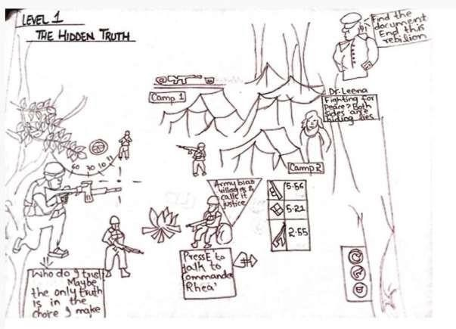
Figure 3.2 Level 1 the Hidden Truth
In Fig 3.3 storyboard represents a more advanced level focused on combat and decision-making, titled Broken Camps.

Key features illustrated:
- Weapon HUD (150/30 ammo display) showing ammunition management
- Enemy detection indicator, representing stealth and alert system

Mission details:
  - Location: Rebels outskirts
  - Time: Early morning (approx. 04:30 hrs)
  - Objective: Destroy rebel camps
- Player combat view, showing a first-person/over-the-shoulder aiming perspective
- Multiple enemies engaging the player, indicating increased difficulty
  - A major highlight of this level is the choice system:
- Follow Army orders → Eliminate all rebels
- Alternative choice → Spare survivors and leave quietly
  - Other elements:
- Visual effects such as explosions, gunfire, and environmental destruction

- Mood description indicating tension, chaos, and intense combat atmosphere
- Flow description showing how enemies react (detect player, call for help, attack)
  - This level emphasizes:
- Tactical gameplay (stealth vs combat)
- Moral decision-making
- Dynamic mission outcomes based on player choice
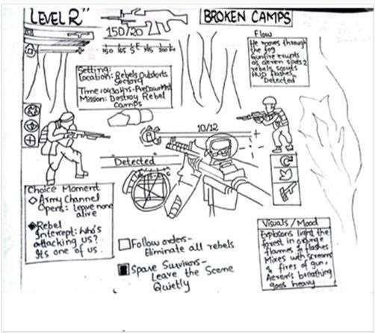
Figure 3.3 Level 2 broken Camps
In Fig 3.4 storyboard illustrates a later stage of the game where the player reaches a critical branching point in the storyline. Based on earlier decisions, the gameplay splits into two different paths.
On one side, the player follows the Army’s perspective, where the objective is to locate and destroy rebel tunnels, which act as their main supply routes. The visuals show soldiers receiving orders and carrying out aggressive actions, reflecting a mission-driven and authoritative approach.
On the other side, the player experiences the Rebel perspective, where the goal shifts to protecting the tunnels from Army attacks. The visuals highlight defensive gameplay, with characters guarding key locations and preparing for incoming enemies.

This scene emphasizes:
- Player choice impacting gameplay direction
- Different objectives based on faction alignment
- Contrast between offensive and defensive strategies
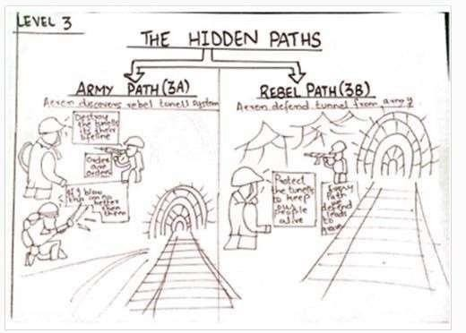

Figure 3.4 Level 3 the hidden paths
This storyboard represents the final outcome of the game, where the story concludes based on the player’s decisions throughout gameplay.
One side shows a scenario where the player supports the Army, leading to the defeat of the Rebels. The visuals include fallen enemies and a secured environment, along with messages indicating mission completion and the end of the rebellion.
The other side presents an alternative outcome where the player aligns with the Rebels. In this case, the environment reflects destruction and conflict aftermath, while dialogue suggests a shift toward freedom and resistance. However, it also hints at consequences such as loss and instability.

This scene highlights:
- Multiple endings based on player decisions
- Moral consequences of choices
Narrative closure of the game
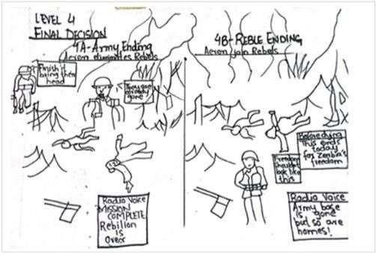
Figure 3.5 Level 4 final decision

Functional Requirements
Functional requirements describe the main features and gameplay systems that Shadow Reclaim must provide. These requirements cover important aspects of the game, including player controls, combat, enemy AI, mission progression, environmental interaction, and decision-making. Defining these requirements helps ensure that all major gameplay features are clearly identified before and during development.
This section presents the functional and non-functional requirements of the system. The functional requirements focus on what the game should allow the player and other game systems to do, while the non-functional requirements describe aspects such as performance, usability, scalability, and stability.

Table 1: Player Mechanics
Table 1 describes the core gameplay actions available to the player. These include basic movement, combat actions, health management, and weapon handling. Together, these mechanics form the foundation of the player's interaction with the game and provide the basic controls required for exploration and combat.

Table 3.1 Player Mechanics

FR ID | Feature | Description
FR-01 | Player Movement | Player can walk, run, and navigate freely within the jungle environment with  smooth animations.
FR-02 | Aiming System | Player can aim weapons using a third-person camera with precision targeting.
FR-03 | Shooting Mechanism | Player can shoot enemies using different weapons with realistic feedback.

FR-04 | Health System | Player has a health bar that decreases upon damage and can be  restored using items.
FR-05 | Reload System | Weapons can be reloaded with animations and ammo tracking.

Table 2: Interaction System
This table describes how the player interacts with the game world. It covers interactions with objects, NPCs, and story elements, enabling immersion and progression through exploration and dialogue.

Table 3.2 Interaction System

FR ID | Feature | Description
FR-06 | Object Interaction | Player can interact with objects such as crates, doors, and documents.
FR-07 | Document Collection | Hidden documents can be collected for story progression and lore.
FR-08 | NPC Interaction | Player interacts with NPCs belonging to different factions.
FR-09 | Dialogue Choices | Player can select dialogue options affecting story outcomes.

Table 3: Enemy AI System
This table outlines the behavior and intelligence of enemy characters. It includes movement patterns, detection mechanisms, and combat responses that create challenge and realism in gameplay.
Table 3.3 Enemy AI System

FR ID | Feature | Description
FR-10 | Enemy Patrol | Enemies patrol designated paths using Unity NavMesh.
FR-11 | Enemy Detection | Enemies detect player within a specific radius and line of sight.
FR-12 | Combat Behavior | Enemies engage in combat when player is detected.
FR-13 | Pathfinding | Enemies navigate terrain and avoid obstacles dynamically.

Table 4: Mission and Level System

This table explains how the game is structured in terms of missions and levels. It defines objectives, progression, and checkpoint systems that guide the player through the storyline.
Table 3.4 Mission And Level System

FR ID | Feature | Description
FR-14 | Mission Objectives | Tasks include exploration, combat, and intel collection.
FR-15 | Level Progression | Game progresses through multiple  structured levels.
FR-16 | Objective Tracking | Current objectives are displayed on screen.
FR-17 | Checkpoint System | Game progress is saved at checkpoints.

Table 5: Decision & Story System
This table focuses on narrative elements and player choices. It highlights how decisions impact the storyline, faction alignment, and the overall outcome of the game.
Table 3.5 Decision and Story System

FR ID | Feature | Description
FR-18 | Choice-Based Decisions | Player decisions impact narrative direction.
FR-19 | Faction Alignment | Player chooses between Army or Rebels.
FR-20 | Multiple Endings | Different endings based on decisions.
FR-21 | Dynamic Missions | Missions adapt based on player choices.

Non-Functional Requirements

Table 6: Performance Requirements
This table specifies system performance expectations such as frame rate, loading time, and efficient resource usage to ensure smooth gameplay.
Table 3.6 Performance Requirements

NFR ID | Requirement | Description
NFR-01 | Frame Rate | Game should maintain at least 30 FPS for smooth  gameplay.
NFR-02 | Load Time | Levels must load within 10 seconds.
NFR-03 | Resource Usage | Efficient CPU and memory usage.

Table 7: Usability Requirements
This table describes user experience factors, including interface design, control responsiveness, and accessibility features to make the game easy to use.
Table 3.7 Usability Requirement

NFR ID | Requirement | Description
NFR-04 | User Interface | UI should be intuitive and user-friendly.
NFR-05 | Controls | Controls must be responsive and easy to learn.
NFR-06 | Accessibility | Adjustable settings like sensitivity.

Table 8: Reliability & Stability
This table defines the system’s ability to function consistently without crashes or errors, ensuring a stable and reliable gaming experience.
Table 3.8 Reliability and Stability

NFR ID | Requirement | Description
NFR-07 | Error Handling | System should handle errors gracefully.
NFR-08 | Stability | Game should run without crashes.
NFR-09 | Save System | Reliable saving of progress.

Table 9: Scalability & Maintainability
This table explains how the system is designed for future growth and easy maintenance, allowing new features to be added without major changes.

Table 3.9 Scalability and Maintainability

NFR ID | Requirement | Description
NFR-10 | Code Maintainability | Code should be modular.
NFR-11 | Scalability | Support future expansion.
NFR-12 | Reusability | Components reusable across levels.

Table 10: Security Requirements
This table outlines measures to protect game data and prevent unauthorized access or modifications, ensuring data integrity and system security.
Table 3.10 Security Requirement

NFR ID | Requirement | Description
NFR-13 | Data Integrity | Game data should remain consistent.
NFR-14 | Unauthorized Access | Prevent unauthorized modifications.

Design and Architecture
The following parts of Software Design Description (SDD) report should be included in this chapter.

System Architecture
Shadow Reclaims design and architecture determine how the different parts of the game are structured, organized and interact with each other to provide a smooth gameplay experience. A well-planned architecture is a must to make sure the system is modular, scalable, maintainable, and efficient throughout the development life cycle.

The game is constructed on a layered architecture approach, where each layer is responsible for a particular set of functionalities. This separation of concerns allows developers to work on different modules independently without impacting the whole system. It also makes debugging, testing and future enhancements easier.

Layered Architecture Overview

The architecture is broken down into different layers that interact with each other to form a structured and well-defined architecture. First is the Core Gameplay layer, which encompasses basic gameplay elements like movement, shooting, health management, and physics. Next up is the AI and Game Logic layer, which is concerned with the behavior of the enemies, including the patrol systems, detection, fighting, and pathfinding through Unity NavMesh technology, as well as their decision making, which determines the way the enemies react towards the player. Next is the Mission and Progression Layer, which takes care of the missions, progressions, checkpoint systems, and overall game flow. On top of this, the Narrative and Decision layer deals with story related elements like dialogue system, faction choice, and decision making, which adapt the storyline based on player's choices and offer multiple endings. Lastly is the User Interface (UI) layer, which controls all the elements shown to the user interface, including menus, HUD elements such as health bar and ammo counter, mission objectives, and dialogue interface elements.

Modular Design Approach
The architecture is designed using a modular approach, where each system (e.g., Player Controller, Enemy AI, Mission Manager, and UI Manager) operates as an independent module. This provides several advantages:
      - Easy to update or modify individual components
      - Reduced dependency between systems
      - Improved code readability and organization

      - Faster development and debugging process

For example, changes in the enemy AI system will not directly affect the player movement system, as both operate independently through defined interfaces.

Separation of Responsibilities
To ensure efficiency and maintainability, responsibilities are clearly divided among different components:
      - Player Controller: Handles movement, aiming, shooting, and interactions
      - Enemy AI System: Manages enemy behavior, detection, and combat
      - Mission Manager: Tracks objectives, level progression, and checkpoints
      - UI Manager: Controls all user interface elements and updates
      - Dialogue System: Handles conversations and player choices

This separation reduces complexity and prevents overlapping functionalities within the system.

Scalability and Maintainability
The architecture is designed with future expansion in mind. New features such as additional levels, weapons, AI behaviors, or story branches can be added without major changes to the existing system. The use of reusable components and clean code practices ensures long-term maintainability.

System Interaction
All components communicate through well-defined interfaces and events. For instance:
      - Player actions trigger AI responses
      - Mission completion updates the UI
      - Dialogue choices influence story progression

This interaction ensures that the game operates as a cohesive system while maintaining modular independence.

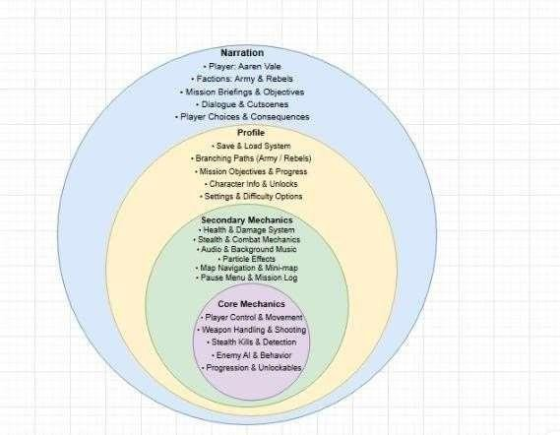
Figure 4.1 Onion Architecture Diagram

Process Flow/Representation
Shadow Reclaim Process Flow The figure demonstrates how the various components of Shadow Reclaim integrate together from the launch of the game until the successful completion of the mission. Through the described process flow the system maintains good co-ordination amongst the game play, game play AI behaviour, Mission handling and the UI. The process is initiated by the player launching the game leading to the initialisation of the game's main menu where players choose to start or continue their existing game play.
Game Play and Game Logic: After game initialisation the player will be introduced to the game world and the core gameplay Layer will come to effect and the player will be in position to execute player inputs such as aiming, firing, moving and interacting with environment object.
The player inputs will constantly and real time effect the environment. Meanwhile the Background game play AI & Game Logic Layer continues to execute where enemies continue patrolling their assigned waypoints and try to identify players via their detection range, upon which enemies turn to combat mode chasing player , or shooting from range or taking cover from gun shots. Mission & Progression Layer While exploring the environment, Mission and progression layer keeps track of players to attain given objectives such as reaching specific location, collecting specific item and or eliminating set numbers of enemies and the UI system will showcase the mission progress. On achievement of player objectives the system updates players progress to save players progress towards missions achievement and can set up checkpoints to save game state.
Story Layer When critical interactions such as dialogues with NPCs or special mission events occur the Story layer becomes triggered where the player will face dialogue options with their chosen options affect either: their aligned side (Army or Rebels) which influence story outcome , future missions, relationships with characters or one of multiple story conclusions.
User interface: the UI continues to be updated and reflect in real-time health, ammunition, mission objective status and available player interactions at all times. Game Failure: should player’s health hit zero the failure condition will be initiated and the system will reload the player into the most recent checkpoint. Completion: Should all mission objectives be cleared game progresses into another level or story progresses.

Design Models
The design model of Shadow Reclaim provides a structured representation of how the system is organized and implemented. It defines the internal structure of the game, including components, their relationships, and how data flows between them. The design model ensures that the system is efficient, modular, and easy to maintain, while also supporting scalability for future enhancements.

Class Diagram
The class diagram shows the static structure of the game system and reveals how the different classes connect to perform the overall functionality of the game. Given that the Game Manager sits at the center of the system, it could indicate that the class controls the complete game flow. It stores information such as the current level and current game state. However, the Game Manager may also provide functions that include starting the game, pausing the game, saving progress, and loading saved data. Game Manager manages Level Manager, handles spawn points and enemy generation.

The Level Manager loads different levels and stores level numbers within the game world. Moreover, the findings suggest that this component also connects with the Save System, which might indicate that data can be saved in slots, loaded, or used to create checkpoints. Furthermore, another connected component, the Ending System, could demonstrate that it determines the final ending of the game based on player decisions, such as the Army ending or the Rebels ending. Nevertheless, the evidence shows that the user interface is controlled by the UI Manager, which appears to update player health, ammunition, and mission objectives on the screen. Menu System controls game menu, lets player start, open settings, exit.

The Decision System represents an important part of the story-based gameplay, and the results indicate that it presents choices to the player and allows selection between Army or Rebels. Given that these decisions affect later levels and endings, the findings may suggest that the diagram also includes different levels, such as Level 1, Level 2, Level 3, and Level 4. Therefore, each level could contain specific objectives and methods, for example tracking player decisions, triggering enemy attacks, unlocking new paths, or activating the final ending sequence. In light of these details, the evidence might indicate that the Player Controller class handles all player actions. Player Controller stores name, health, ammo, faction, inventory, position.

However, the significant data could show that the class also provides actions like movement, aiming, shooting, crouching, jumping, interacting, making decisions, and saving progress. Moreover, the player connects to a Weapon class, which may suggest that it manages firing and reloading actions. Additionally, the player owns an Inventory, where the important findings indicate that collected items are stored. Thus, these items appear to be represented by the Item class, which includes item name, amount, and type. Player interacts with Terminal, unlocks doors, grants mission access.

Input commands pass through the Player Input Handler, and the evidence could indicate that this component receives movement, camera look, and firing inputs from the player. Nevertheless, enemy behavior may be represented through the Enemy class, and the findings suggest that each enemy has a type, health, faction, and position. Furthermore, the results demonstrate that enemies can patrol, chase the player, attack, and die during combat. Given that their intelligence is controlled through the AI Controller, the significant evidence might indicate that this system uses navigation agents, behavior trees, and enemy vision. Faction Manager controls Army and Rebel relationships, updates reactions to player choices.

Therefore, the Animation System could demonstrate that it plays character animations such as idle, walking, shooting, enemy death, and combat actions, and the key findings may suggest that this makes the gameplay visually interactive..

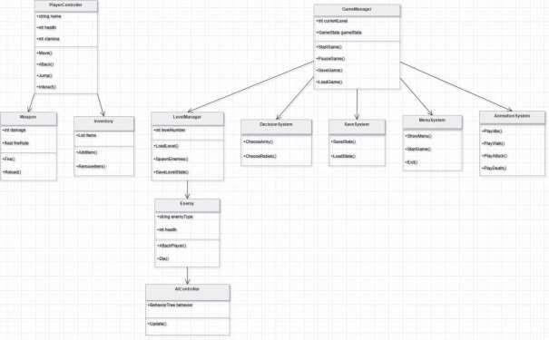
Figure 4.2 Class Diagram

Sequence Diagram
The sequence diagram explains how different objects and systems interact over time during gameplay. The process begins when the player opens the game. The player first interacts with the Menu System by selecting the Start Game option. The Menu System sends a request to the Game Engine, which initializes the game and passes control to the Level Manager. The Level Manager loads Level 1, places the player in the world, and spawns enemies in the environment. Once the level is ready, gameplay begins.

During gameplay, the player performs actions such as movement, attacking enemies, and exploring the environment. These actions are sent to the Game Engine, which updates the player state and requests animations from the Animation System. For example, if the player attacks, the Animation System plays attack animations, while the AI/Enemies system reacts by entering combat mode. Enemy units may chase the player, fire weapons, or defend positions depending on their AI behavior.

At a key point in the sequence, the player reaches a decision event. The system presents a choice where the player can support either the Army faction or the Rebels faction. This choice creates two different branches in the game sequence. If the player chooses the Army path, the Level Manager loads missions such as defending the army base, attacking rebel commanders, and participating in heavy combat missions. If the player chooses the Rebels path, the Level

Manager loads missions such as attacking army outposts, rescuing allies, and battling army forces.
After completing the selected missions, the Level Manager loads the final level or ending scene. The Ending System then checks all decisions and mission results to determine the final outcome. Appropriate ending animations are played through the Animation System. Once the ending is completed, the player is returned to the main menu where they can restart the game or exit.

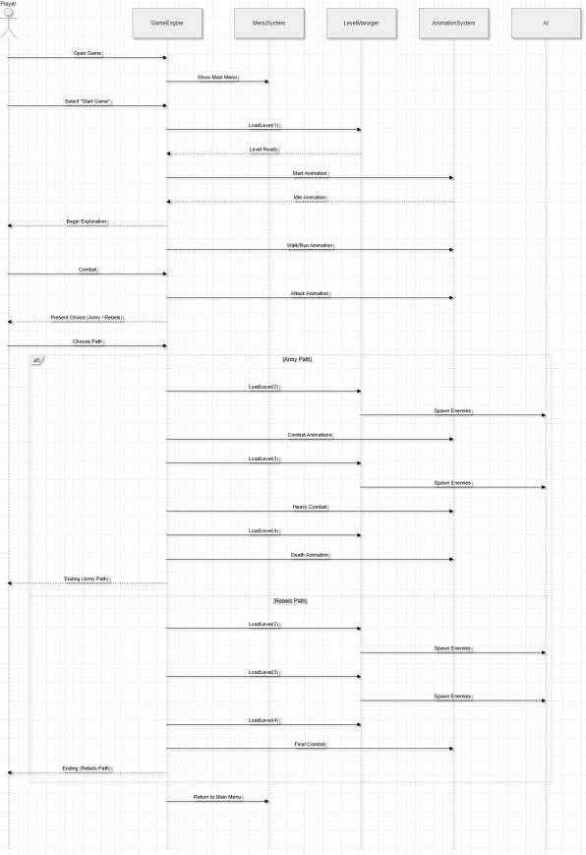
Figure 4.3 Sequence Diagram

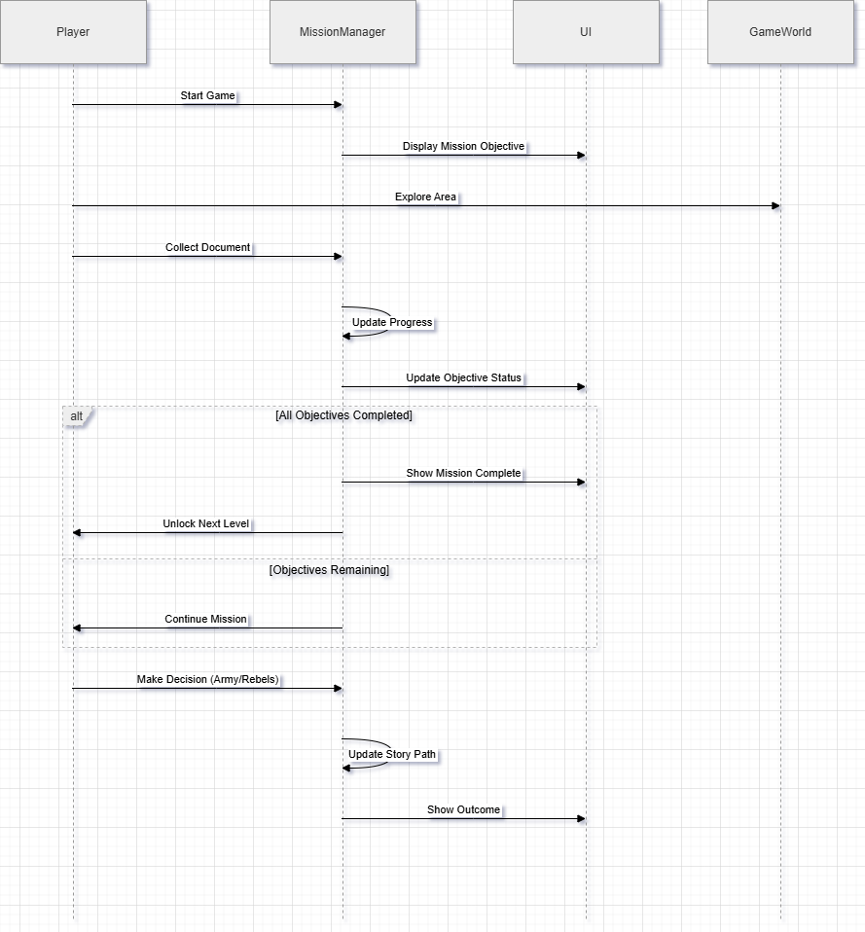
Figure 4.4 Sequence Diagram for Mission

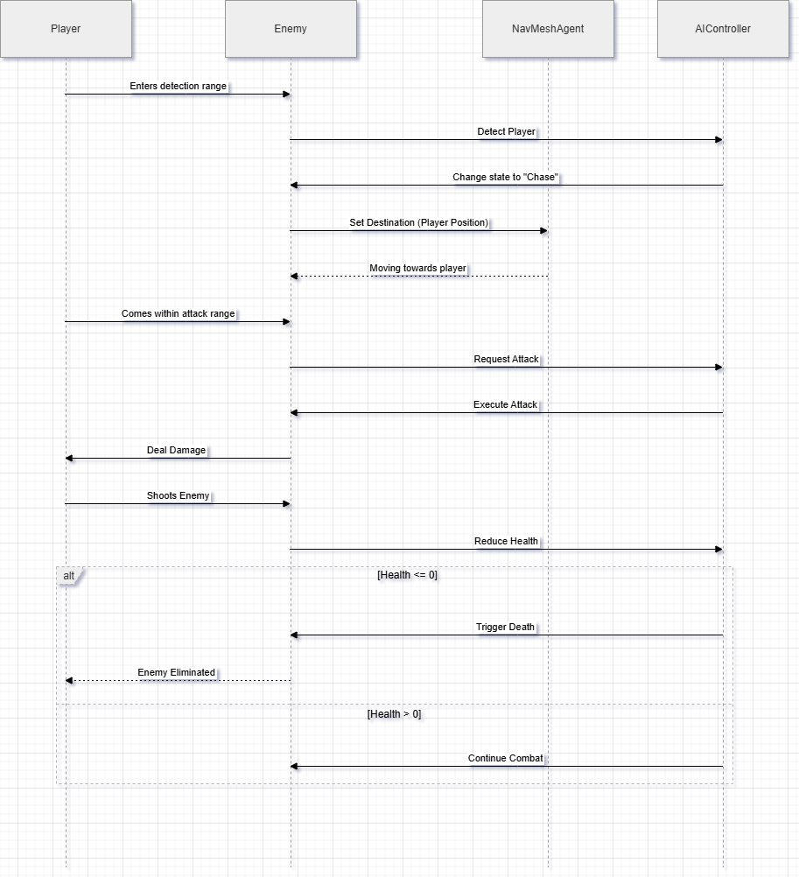
Figure 4.5 Sequence Diagram for Enemy

Activity Diagram
The activity diagram represents the complete workflow and logic of the game from start to finish. The process starts at the initial node when the player launches the game. The first activity is opening the main menu. From there, the player can choose to start the game, open settings, or exit the application. If the player chooses settings, they can adjust game preferences and then return to the menu. If the player exits, the workflow ends.

If the player selects Start Game, the system loads the introduction and first level. The player then begins gameplay by moving through the environment, fighting enemies, collecting items, and completing objectives. During gameplay, decision points appear where the player must choose whether to support the Army or the Rebels. This decision creates two separate activity paths.

In the Army branch, the player performs missions such as defending the army base, attacking rebel camps, and eliminating rebel leaders. In the Rebels branch, the player performs missions such as sabotaging army defenses, rescuing captured allies, and defeating army commanders. Each mission completed moves the player to the next activity in the sequence.

Throughout the workflow, the player may collect weapons, documents, or other important items. The player may also use terminals to unlock doors or gain access to restricted areas. Combat activities include shooting enemies, avoiding attacks, and surviving battles. The system continuously checks whether mission objectives are completed. If not, the player repeats tasks until successful.

Once all missions are completed, both branches merge into the final stage of the game. The Ending System evaluates player choices, faction loyalty, and mission outcomes to determine the final ending scene. After the ending is shown, the workflow reaches the final node and the game ends.

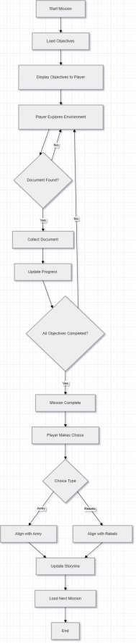

Figure 4.6 Activity Diagram for Mission

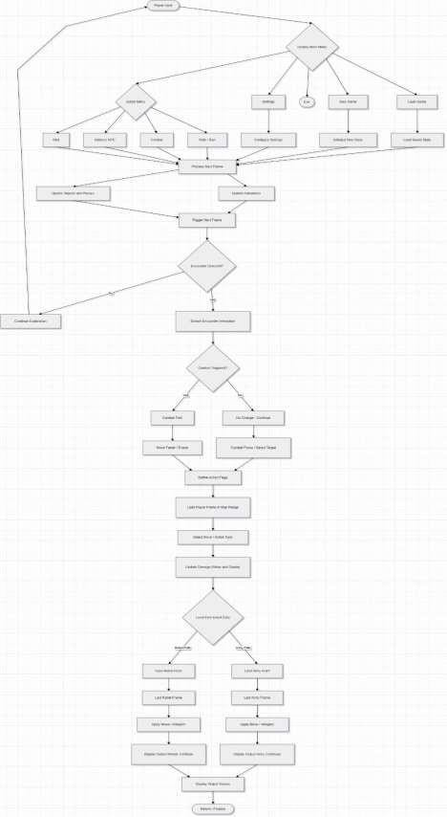
Figure 4.7 Activity Diagram

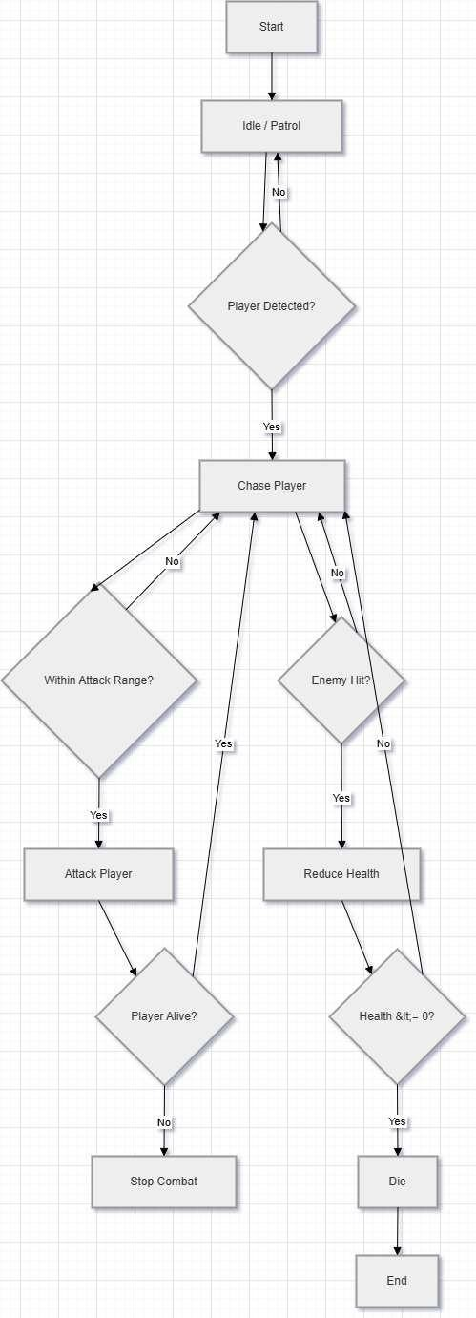
Figure 4.8 Activity Diagram for Enemy

Implementation
This chapter provides a comprehensive explanation of the implementation of the project Shadow Reclaim. It describes the core gameplay systems, implementation algorithms, external tools, and user interface components that together build the complete functionality of the game. The chapter begins by presenting the major algorithms used in the game such as player movement, combat mechanics, enemy AI, mission progression, and inventory management.
Finally, the chapter presents the user interface developed for the player, including the main menu, gameplay HUD, inventory system, mission objectives, weapon selection, health display, and pause menu.

Algorithm
This section describes the logic, execution flow, and implementation of the primary gameplay systems within Shadow Reclaim. These algorithms ensure smooth gameplay by managing player movement, combat, enemy behavior, mission objectives, and item collection.

Player Movement and Controller System
The objective and algorithm steps for the player movement and controller system are as follows.

Objective:
The objective is to provide smooth and responsive third-person player movement across different environments such as jungles, villages, military bases, caves, and enemy camps.

Algorithm Steps:
Following are the Algorithm Steps,
Input Capture: Read player inputs for movement, sprinting, crouching, jumping, aiming, and interaction.
Movement Calculation: Convert player input into movement directions relative to the camera orientation.
Animation Handling: Play appropriate animations including idle, walk, run, crouch, jump, climb, and roll.
Collision Detection: Prevent the player from passing through obstacles, walls, rocks, and environmental objects.
Camera Follow: Use Cinemachine to smoothly follow the player while maintaining dynamic camera angles during exploration and combat.

Weapon and Combat System
The objective and algorithm steps of the weapon and combat system are as follows.

Objective:
Allow players to engage enemies using different weapons while providing realistic shooting mechanics and combat interactions.

Algorithm Steps:
Weapon Selection: Equip the selected weapon from the player's inventory.

Aim Detection: Calculate the target position using the player's camera direction.

Fire Mechanism: Spawn bullets or perform raycast shooting upon player input.

Damage Calculation: Reduce enemy health according to weapon damage values.

Enemy Elimination: Remove defeated enemies and update mission progress when objectives are completed.

Enemy AI and Detection System
The objective and algorithm steps of the enemy AI system are as follows.

Objective:
Implement intelligent enemy behavior capable of patrolling, detecting the player, chasing targets, and attacking during combat.

Algorithm Steps:
Patrol Movement: Enemies move between predefined patrol points using Unity NavMesh.

Player Detection: Detect the player using vision range and raycasting techniques.

Alert State: If the player is detected, enemies enter combat mode and begin chasing.
Attack Execution: Enemies attack when the player is within weapon range.

Return to Patrol: If the player escapes detection, enemies return to their original patrol routes.

Mission Progression System
The objective and algorithm steps of the mission progression system are as follows.

Objective:
Manage story progression by tracking mission objectives, completed tasks, and player decisions throughout the game.

Algorithm Steps:
Mission Initialization: Load the current mission objectives.
Objective Tracking: Monitor player actions required for mission completion. Progress Validation: Verify that all required objectives have been completed. Mission Completion: Unlock the next mission and reward the player.
Story Update: Update the storyline based on the player's choices and completed objectives.

Inventory and Item Collection System
The objective and algorithm steps of the inventory system are as follows.

Objective:
Allow players to collect and manage weapons, ammunition, medical kits, keys, and mission-related items.

Algorithm Steps:
Item Detection: Detect collectible items when the player enters interaction range.
Interaction: Collect the item when the interaction key is pressed.

Inventory Update: Store the collected item in the player's inventory.

Item Usage: Allow the player to use health kits, equip weapons, or access 111mission items.

Mission Synchronization: Update mission objectives if the collected item is required for story progression.

Save and Checkpoint System
The objective and algorithm steps of the save and checkpoint system are as follows.

Objective:
Store player progress and restore gameplay from the most recent checkpoint.

Algorithm Steps:
Checkpoint Activation: Save progress automatically when the player reaches a checkpoint.

Data Collection: Store player position, health, inventory, weapons, and completed missions.

Serialization: Convert gameplay data into JSON format.

Load Progress: Restore the saved data when the player resumes the game.

Health and HUD Management System
The objective and algorithm steps of the health and HUD management system are as follows.

Objective:
Display real-time player information including health, ammunition, mission objectives, and equipped weapon during gameplay.

Algorithm Steps:
Health Monitoring: Continuously update the player's health status.
Ammo Tracking: Display the current and remaining ammunition.

Objective Display: Show active mission objectives on the gameplay screen.

Weapon Display: Update the equipped weapon icon and related information.

Game Over Check: If player health reaches zero, display the game over screen and reload the latest checkpoint.

External Tools and APIs
The development of Shadow Reclaim involves the use of various external tools, game engines, and Application Programming Interfaces (APIs). This section highlights the Unity modules, third-party libraries, and external resources used during the development of the game. These APIs provide essential functionalities such as character movement, enemy navigation, physics simulation, animation, audio management, camera control, and game data management.

The integration of external APIs simplifies complex development tasks and ensures efficient communication between different game modules. These tools improve the overall gameplay experience by providing smooth performance, realistic interactions, and reliable game mechanics.

Table 5.1 shows a comprehensive overview of the external tools and APIs used in the development of Shadow Reclaim, along with their descriptions, purposes, and implementation classes.

Table 5.1 External Tools and APIs Used in the Project
Name |  | Purpose in Game | Class / Function Used
Unity Engine | Industry-standard game engine for 3D game  development | Core rendering, scripting, physics  simulation, scene management | PlayerController.cs, GameManager.cs
Cinemachine | Unity camera  system for dynamic camera  movement | Third-person camera follow, aiming, and cinematic cutscenes | CameraController.cs
Unity NavMesh | Built-in AI navigation system | Enemy patrol, pathfinding, and player chasing | EnemyAIController.cs
Input System | Unity input management package | Handle player movement, combat,  interaction, and weapon controls | PlayerInputHandler.cs
Animator Controller | Unity animation management  system | Character movement, combat animations,  enemy animations | Animation Controller.cs
Physics Engine | Unity built-in physics engine | Collision detection, gravity, explosions,  and environmental interaction | Physics Manager.cs
Audio Source API | Unity audio management component | Background music,  weapon sounds,  footsteps, and environmental effects | Audio Manager.cs
JSON Utility API | Unity JSON serialization  library | Save and load player progress and game data | Save Manager.cs
Particle System | Unity visual effects system | Gunfire effects,  explosions, smoke, blood effects, and environmental  particles | Effects Manager.cs
Terrain System | Unity terrain creation tool | Design forests, mountains, villages,  rivers, and military camps | Unity Terrain Components

User Interface
The user interface of Shadow Reclaim is designed to provide a simple, interactive, and user-friendly gaming experience. It includes player menus, gameplay HUD, mission objectives, inventory management, weapon selection, pause menu, and ending screens. Every interface element is designed to help the player understand objectives while maintaining immersion during gameplay.

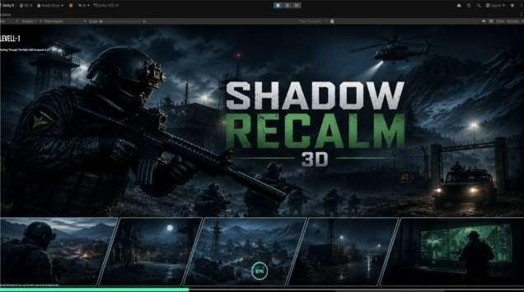

Main Menu Screen
The Main Menu is displayed when the game starts. It provides simple navigation options that allow the player to begin a new game, continue a saved game, access settings, or exit the application.

The below Figure 5.1 shows the Main Menu screen of Shadow Reclaim.

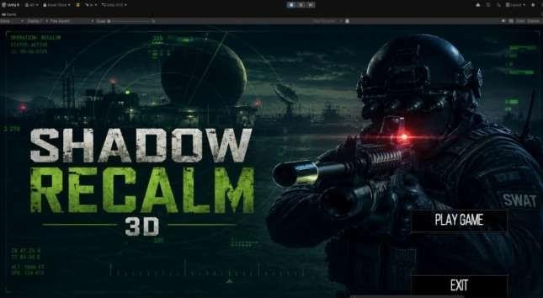
Figure 5.1 Main Menu Screen of Shadow Reclaim

Introduction Cutscene Screen
This screen displays the opening cinematic of the game. It introduces the player to the country of Zerbia, the ongoing conflict between the Army and the Rebels, and the player's first mission. During the cutscene, player controls are disabled while important story events are presented.
The below Figure 5.2 shows the Introduction Cutscene of Shadow Reclaim.
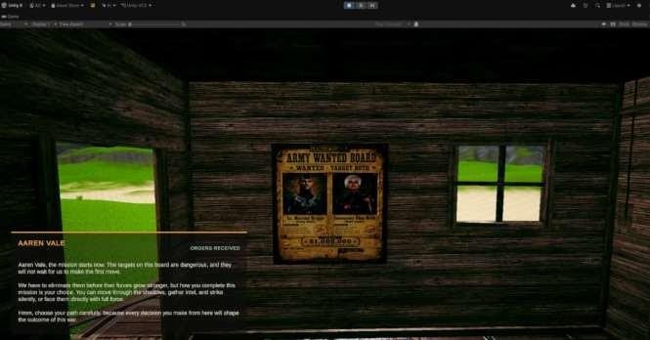
Figure 5.2 Introduction Cutscene Screen

Player HUD (In-Game Interface)
This interface displays important gameplay information including the player's health, ammunition count, equipped weapon, compass, mission objectives, and mini-map. These HUD elements help the player monitor combat status and mission progress throughout the game.
The below Figure 5.3 shows the Player HUD of Shadow Reclaim.

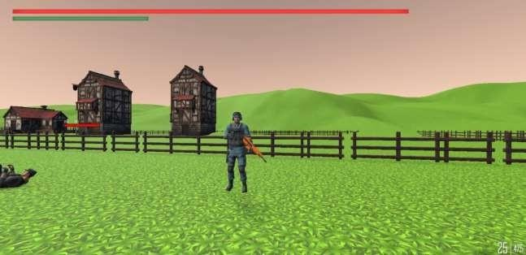

Figure 5.3 Player HUD (In-Game Interface)

Combat Interface
The Combat Interface appears whenever the player engages enemy soldiers. It displays hit indicators, enemy damage effects, crosshair feedback, weapon recoil, and health updates during firefights.

The below Figure 5.4 shows the Combat Interface of Shadow Reclaim.
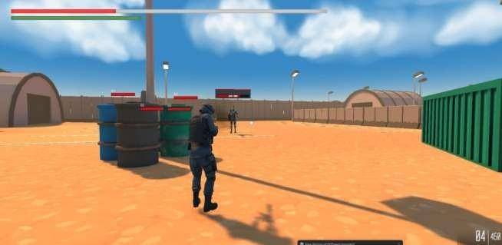
Figure 5.4 Combat Interface

Mission Objective Screen
This interface presents the current mission objectives, completed tasks, and updated mission information throughout the game. It helps the player understand mission requirements and overall story progression.

Pause Menu Screen
The Pause Menu allows the player to temporarily stop the game and access additional options including Resume Game, Settings, Controls, Save Progress, Load Game, and Exit to Main Menu.

Bomb Placement Interaction Interface
This interface appears when the player reaches the mission objective where an Explosive device must be planted. The HUD displays the instruction "Crouch And Hold 'B' to Place Bomb" along with an interaction button. Once the player Performs the required action, the bomb is planted and the mission progresses to The next objective.
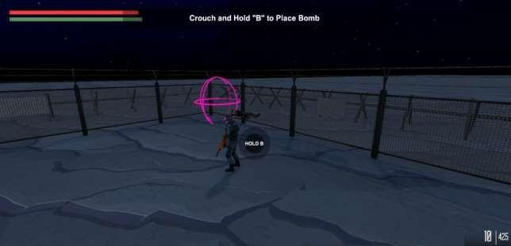
Figure 5.7 Mission Marker Interface

Bomb Mission Objective Interface
This interface is displayed during the bomb placement mission in Shadow Reclaim. It shows the current mission objective, which requires the player To place explosive devices at multiple designated locations within the enemy Base. The mission progress counter updates each time a bomb is successfully Planted. The interface also displays the player's health, stamina, and Ammunition to assist the player throughout the mission.

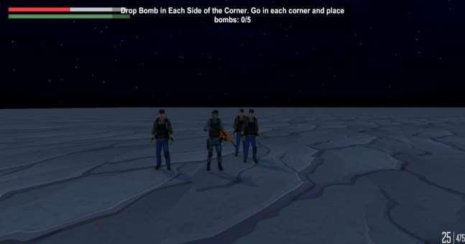
Figure 5.8 Bomb Mission

Mission Success Cutscene Screen
This screen displays the cinematic cutscene that plays immediately after the Successful completion of a mission in Shadow Reclaim. It showcases the Aftermath of the operation, including the explosion of the enemy objective And the safe extraction of the player's team. The cutscene enhances the Storytelling experience by providing a smooth transition between completed Missions and the next stage of the game. Players can skip the cutscene by Pressing the 'E' key.
The below Figure 5.15 shows the Mission Success Cutscene Screen of Shadow Reclaim.

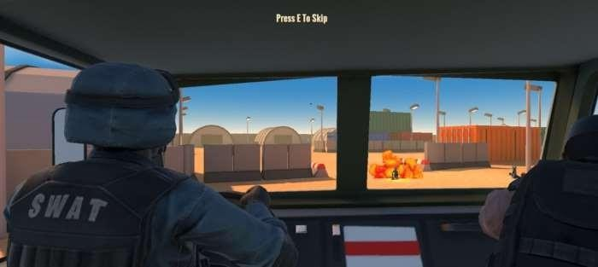

Figure 5.9 Mission Success Cutscene Screen of Shadow Reclaim

Final Cutscene and Ending Screen
The Final Cutscene presents the conclusion of the player's journey after the final mission. Depending on the player's decisions throughout the game, different cinematic endings are displayed that determine the future of Zerbia and the outcome of the conflict between the Army and the Rebels.

The below Figure 5.11 shows the Final Cutscene and Ending Screen of Shadow Reclaim
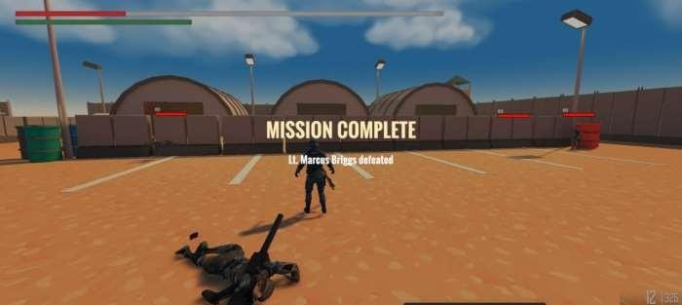
Figure 5.10 Final Cutscene and Ending Screen

Combat and Enemy Engagement Scene
During this combat sequence, Aaren Vale engages in an intense firefight. Explosions, fire, and enemy attacks create a high-risk environment as the player uses weapons and tactical movement to eliminate hostile Forces while progressing toward the mission objective. This scene Demonstrates the game's combat mechanics, enemy AI behavior, and Action-oriented gameplay.
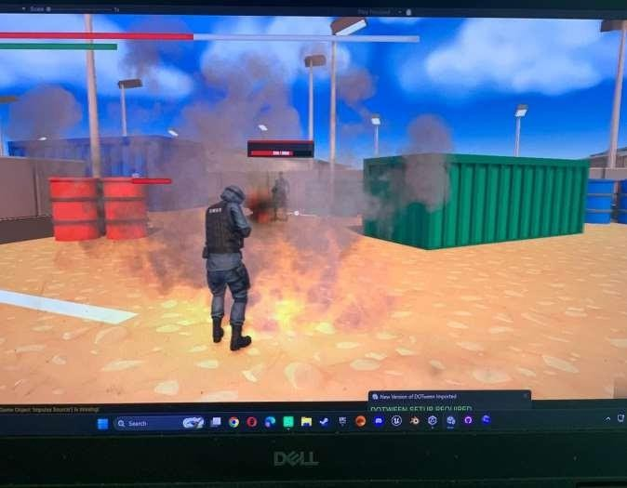
5.11. Final Combat and Enemy Screen

Testing and Evaluation
During the development of the Shadow Reclaim game, extensive testing was performed to ensure that all game components functioned correctly and satisfied the defined functional and non-functional requirements. Different testing techniques were applied throughout the development process to verify gameplay mechanics, player interactions, enemy artificial intelligence, mission flow, user interface, and overall game stability.
The testing process helped identify implementation issues at an early stage and ensured that all gameplay systems worked together smoothly. Both manual and automated testing approaches were used to validate the reliability, performance, and responsiveness of the game.

Manual Testing
The project was manually tested by comparing the expected and actual results to verify that every gameplay feature behaved as intended under real gameplay conditions. Manual testing included evaluating player movement, enemy AI behavior, combat mechanics, mission progression, interactive objects, cutscenes, and user interface elements to ensure a smooth and immersive gaming experience.

System Testing
System testing includes the validation of the complete functionality of the game and ensures that all major components such as player movement, enemy AI, combat system, missions, interactions, and cutscenes work together correctly.

Table 6.1 shows the System Testing performed for the Shadow Reclaim game.

Table 6.1: System Testing

Test Case | Description | Expected Result | Actual Result | Status
Player Movement | Player moves smoothly with correct animations | Movement is smooth and animations trigger correctly | Movement works smoothly with  all animations | Pass
Enemy AI Detection | Enemy detects player when entering detection  Range | Enemy detects player and starts chasing | Enemy AI detects player  Correctly | Pass
Shooting System | Player fires weapon during combat | Weapon fires successfully and ammunition decreases | Shooting system  functions correctly | Pass
Mission Progression | Complete mission objectives | Objectives update and next mission unlocks | Mission  progression works correctly | Pass
Interactive System | Player interacts with mission objects | Interaction is performed successfully | Object interaction  works correctly | Pass
Cutscene Trigger | Story cutscenes play at specific missions | Cutscenes load and play smoothly | Cutscenes trigger without | Pass

The system testing confirms that all major gameplay systems of Shadow Reclaim operate correctly and provide a stable gaming experience.

Unit Testing
Unit testing includes the validation and testing of individual scripts and gameplay systems such as the player controller, shooting mechanics, health system, enemy AI, interaction system, and save functionality. Each module was tested independently to verify its expected behaviour before integration into the complete game.
Table 6.2: Player Controller Unit Test Case

No. | Test Case / Test Script | Attribute and Value | Expected Result | Result
1 | Test Player Movement | Press WASD keys | Player moves forward, backward, left and right smoothly | Pass
2 | Test Jump Function | Press Space | Player jumps with correct physics | Pass
3 | Test Mechanic | Press Ctrl | Player enters crouch mode successfully | Pass
4 | Test Sprint Function | Hold Shift while moving | Player movement speed increases | Pass

Table 6.3: Shooting System Unit Test Case

No. | Test Case / Test Script | Attribute and Value | Expected Result | Res ult
1 | Verify Weapon Fire | Left  Mouse Click | Weapon fires successfully | Pass
2 | Verify Ammo Reduction | Fire  multiple bullets | Ammunition decreases correctly | Pass
3 | Verify Reload System | Press R | Weapon reloads correctly | Pass
4 | Verify Weapon Switching | Scroll  Mouse Wheel | Equipped weapon changes successfully | Pass

Table 6.4: Health System Unit Test Case

No. | Test Case / Test Script | Attribute and Value | Expected Result | Result
1 | Verify Player Damage | Enemy attacks player | Player health decreases correctly | Pass
2 | Verify Health Recovery | Use Health Kit | Player health increases | Pass
3 | Verify Player Death | Health reaches zero | Game Over screen appears | Pass

Table 6.5: Enemy AI Unit Test Case
No. | Test Case / Test Script | Attribute and Value | Expected Result | Result
1 | Verify Enemy Detection | Player enters detection range | Enemy detects player | Pass
2 | Verify Enemy Chase | Player runs away | Enemy follows player using NavMesh | Pass
3 | Verify Enemy Attack | Player enters attack range | Enemy attacks player | Pass
4 | Verify Patrol Behaviour | Player leaves detection range | Enemy returns to patrol route | Pass

Table 6.6: Interaction System Unit Test Case

No. | Test Case / Test Script | Attribute and Value | Expected Result | Result
1 | Verify Object Interaction | Press E near interactive object | Interaction executes successfully | Pass
2 | Verify Invalid Interaction | Press E away from objects | No interaction occurs | Pass
3 | Verify Mission Object Collection | Collect mission document | Item added and objective updated | Pass

Table 6.7: Save System Unit Test Case

No. | Test Case / Test Script | Attribute and Value | Expected Result | Result
1 | Verify Save Function | Reach checkpoint | Game progress saved | Pass
2 | Verify Load Function | Load saved game | Previous game state restored | Pass
3 | Verify Mission Restoration | Resume saved mission | Mission progress restored correctly | Pass

Table 6.8: Play Testing Results

No. | Play Testing Scenario | Tester Feedback / Observation | Expected Result | Result
1 | Game Launch | Game starts without errors. | Main menu loads successfully. | Pass
2 | Movement | Players can move,  jump, sprint, and crouch smoothly. | Character  controls respond correctly. | Pass
3 | Combat | Weapons fire, reload, and switch correctly. | Combat mechanics function as  intended. | Pass
4 | Enemy AI | Enemies detect, chase,  and attack appropriately. | AI behaves  according to design. | Pass
5 | Mission Gameplay | Objectives update after | Mission | Pass

 |  | collecting items. | progression works correctly.
6 | Save/Load | Checkpoint saves and restores progress. | Saved game loads correctly. | Pass
7 | User Experience | UI is clear and gameplay is enjoyable. | Positive player experience. | Pass

Conclusion and Future Work
This chapter presents the conclusion of the Shadow Reclaim project, followed by a discussion of possible future enhancements and research directions that can further improve the game.

Conclusion
Shadow Reclaim is a third-person action and shooter game that provides an immersive gaming experience by combining exploration, tactical combat, stealth mechanics, mission-based gameplay, and story-driven decision making. Throughout the game, players travel across different environments such as jungles, villages, military bases, and enemy camps while completing missions that contribute to the overall storyline. Moreover, the game may allow players to engage in intense combat, interact with mission objectives, and collect important resources that could influence the progression of the story. Game shows shooting mechanics, enemy AI, exploration, mission completion, and interactive systems together.

However, the implementation may suggest that the results demonstrate a focus on delivering smooth player controls, responsive combat mechanics, and intelligent enemy behaviour. Given that the evidence indicates a user-friendly interface, results might indicate that this feature enhances the overall gameplay experience. Therefore, the significant findings could show that the game achieves its primary objectives by providing a realistic 3D environment where players experience dynamic gameplay. Nevertheless, the project may present that development relied on the Unity Game Engine and the C# programming language, following a modular software architecture that promotes maintainability, scalability, and code reusability. Design allows new features, missions, weapons, environments, and characters added with minimal changes.

Furthermore, the important findings may reveal that this structured approach simplifies debugging, testing, and future development. In light of these results, the study might demonstrate that modern game development technologies and organized software engineering practices combine to create an engaging and interactive gaming experience. Additionally, the relevant evidence could indicate that the project reflects the team's technical knowledge, creativity, and collaborative effort while providing a solid foundation for future improvements. Given that player expectations continue to evolve, the architecture appears to support future enhancements without affecting the stability of existing gameplay systems. Architecture supports future updates without breaking existing systems.

Future Work
The current version of Shadow Reclaim may suggest that it provides a strong foundation for a story-driven third-person shooter game. However, the findings indicate that several opportunities exist for future improvements that could enhance the gameplay experience and overall quality of the project. Moreover, future versions might introduce additional story missions, side quests, and character-driven narratives that may provide players with a longer and more engaging campaign. Therefore, new playable characters, advanced enemy types, boss battles, and faction-based missions could also be added to increase gameplay variety and replayability. Study shows decision system expands through branching storylines and multiple endings.

Nevertheless, the combat system may suggest further enhancement through additional weapon categories, customizable attachments, advanced cover mechanics, grenade systems, and improved tactical gameplay. In light of these findings, more interactive environments, destructible objects, and dynamic weather effects could also be implemented to create a more realistic battlefield experience. Thus, artificial intelligence may present another area that offers significant opportunities for improvement. Given that future updates are considered, results might indicate smarter enemy behaviours such as coordinated squad attacks, strategic flanking, adaptive combat techniques, and improved pathfinding. Companions assist players and support cooperative gameplay.

Additionally, the relevant evidence may suggest that improvements include larger open-world environments, improved environmental assets, high-quality cinematic cutscenes, professional voice acting, and multilingual language support. Furthermore, the significant data could indicate that technical enhancements such as cloud-based save systems, multiplayer functionality, online cooperative missions, and cross-platform support may further improve the overall quality and accessibility of the game. However, the important results suggest that with these future enhancements, Shadow Reclaim has the potential to evolve into a complete, professional-quality third-person action game. Therefore, the study may demonstrate that this evolution could deliver an immersive, engaging, and memorable experience for players while showing advanced game development and software engineering practices.

References
- Unity, Unity Manual. Available: https://docs.unity3d.com/
- Visual Studio, Microsoft Visual Studio Documentation. Available: https://learn.microsoft.com/visualstudio/
- Unity NavMesh, Unity AI Navigation (NavMesh). Available: https://docs.unity3d.com/Manual/nav-NavigationSystem.html
- Git, Git Documentation. Available: https://git-scm.com/doc
- Blender, Blender Manual. Available: https://docs.blender.org/manual/
- Adobe Photoshop, Adobe Photoshop User Guide. Available: https://helpx.adobe.com/photoshop/user-guide.html
- Game Programming Patterns. Genever Benning, 2014.
- Artificial Intelligence for Games, by Ian Millington and John Funge, CRC Press, 2016.
- The Art of Game Design: A Book of Lenses, by Jesse Schell, CRC Press, 2019.
- Introduction to Game Development, by Steve Rabin, Cengage Learning.


